Subject: Explanation Required for Unauthorized Absence Without Leave - Saleem Farooq (MTS).
You were found absent from your duties without official leave on 19-06-2025.This unauthorized absence is a grave breach of the attendance and leave policies, which strictly require all employees to obtain prior approval for any absence. Furthermore, it has been specifically noted that you were assigned duties for today, and you failed to inform your concerned head regarding your non-availability, causing significant disruption.
You are hereby directed to submit a comprehensive written explanation for your unauthorized absence within two (2) calendar days from the date of this notice. Your explanation must clearly detail the reasons for your absence.
Be informed that failure to provide a satisfactory explanation within the stipulated two-day period will result in immediate and severe disciplinary action, as per the established rules and regulations.

No: KGP/Estt/2025/400
Dated:19-06-2025

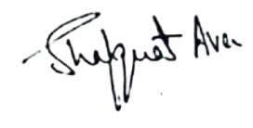

Principal
Kashmir Government Polytechnic College
Srinagar

